Attachment A

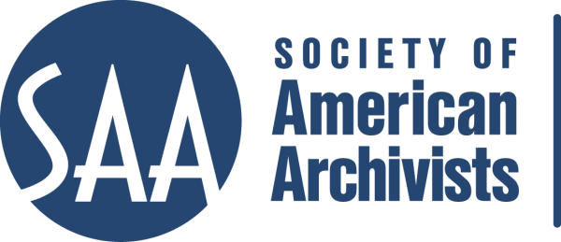

Society of American Archivists
Committee on Education Meeting
February 25-26, 2016
Chicago, Illinois

February 25 - 8:00 am to 7:00 pm
February 26 – 8:00 am to Noon
Breakfast - 8:00 to 8:30 am
Lunch - Noon to 1:00 pm

- Welcome/Introductions – Pelose

- Review and Approval of the Agenda – Pelose (Attachment A)

- Update on DAS – Ghaznavi
  - Status of Courses/Exams/Webinars
  - Status of Comprehensive Exam
  - Exam Question Presentation
    - Exercises

- Black/Carlson Update (10:30 am)
  - A&D announcement – Goodley (Attachment G)

- SAA Education Staff Report – De Sutter (Attachment B)

- ACE Guidelines – Oliff (Attachment C)

- Pre-conference Line-up (at this time) – De Sutter (Attachment D)

- Resources Guide for Students and New Professionals – Clemens

- A&D Program – Liaisons – Reviews/Suggestions
  - Fundamentals of A&D – Houston
  - DACS – Pelose
  - MARC for Archival Description – Clemens
  - EAD – Kiesling/Buchanan
  - Overview of Metadata – Clemens
  - Ethics for Archivists – Oliff
  - Forming Names According to RDA – Part I - Pelose
  - Appraisal for A&D – Gieringer
  - Confidentiality and Privacy Issues in Digital Archives [DAS] – Myers
  - Copyright Issues in Digital Archives [DAS] - Myers
  - A&D of Electronic Records Parts 1 & 2 [DAS] – Faulder
  - Architectural Records: Managing Design & Construction Records – Goodley
  - Fundamentals of Project Management for Archivists – Dine/Myers
  - Photographs: Archival Principles & Practices – Clemens/Flynn
  - Copyright Issues in Digital Archives [DAS] – Myers
  - Grant Writing for A&D – Gieringer
  - A&D for AV Materials – Goodley
  - Style Sheets for EAD… - Kiesling/Oliff
CoE 2/2016
Page 2

  - Financial Management for Archivists – Dine/Houston
  - Forming Names According to RDA – Part II - Clemens
  - Implementing MPLP – Houston/Dine
  - SAA Standard: EAC-CPF - Houston

- Other:
  - Workshop on managing and understanding maps? – Goodley
  - Basics of Preservation for Archives – Flynn
  - AV Digitization Proposal - Goodley

- Vendor Guideline Questions – De Sutter (Attachment E)

- Review of CoE charge and description – Faulder/Goodley (Attachment F)

- Student Program Subcommittee of the 2016 Program Committee - Dine

- Pease Award Update – Clemens

- New Business

- Future Conference Calls
Current call dates are: 3/22; 4/5; 5/17; 6/14; 7/12;
Face-to-face meeting in Atlanta: 8/3 from 8:00 am to 2:00 pm

- Adjournment

